MINI PROJECT

(SESSION-2020-2021)

**Build and deploy a website for ordering pizzas that satisfies the hunger of our customers in just few clicks.**

Pizz360

Report



**Institute of Engineering & Technology**

**Team Members**

**Aryan Saxena**

**(181500136)**

**Divyansh Garg**

**(181500222)**

**Ishika Dubey**

**(181500283)**

## Supervised By

**MR.ANAND GUPTA**

**TECHNICAL TRAINER**

**Department of Computer Engineering &Websites**

**Department of Computer Engineering and Applications**

**GLA University, Mathura**

**17 km. Stone NH#2, Mathura-Delhi Road, P.O. – Chaumuha,**

**Mathura – 281406**



**Declaration**

I hereby declare that the work which is being presented in the Mini Project **“Pizz360”,** in partial fulfillment of the requirements for Mini project Lab is an authentic record of my own work carried under the supervision of **Mr. Anand Gupta, Technical Trainer.**

**Aryan Saxena**

**Divyansh Garg**

**Ishika Dubey**

**Department of Computer Engineering and Applications**

**GLA University, Mathura**

**17 km. Stone NH#2, Mathura-Delhi Road, P.O. – Chaumuha,**

**Mathura – 281406**



**Certificate**

This is to certify that the project entitled “Pizz360” carried out in Mini Project – I I Lab is a

legitimate work done by Aryan Saxena (181500136), Divyansh Garg (181500222), IshikaDubey (181500283) and is submitted in partial fulfillment of the requirements for the award of the degree Bachelor of Technology (Computer Science & Engineering).

**Signature of Supervisor:**

**Name of Supervisor: Mr. Anand Gupta**

**Date: 25/11/2020**

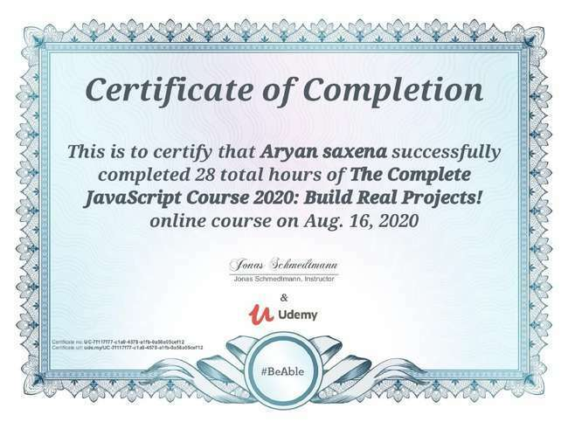



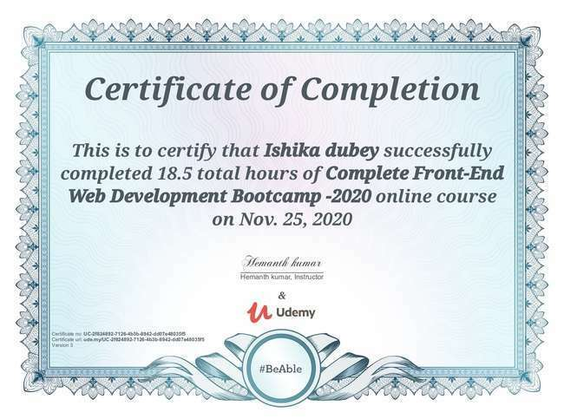

**ACKNOWLEDGEMENT**

It gives us a great sense of pleasure to present the report of the B. Tech Mini Project undertaken during B. Tech. Third Year. This project in itself is an acknowledgement to the inspiration, drive and technical assistance contributed to it by many individuals. This project would never have seen the light of the day without the help and guidance that we have received.

Our heartiest thanks to Dr. (Prof). Anand Singh Jalal, Head of Dept., Department of CEA for providing us with an encouraging platform to develop this project, which thus helped us in shaping our abilities towards a constructive goal.

We owe special debt of gratitude to Mr. Anand Gupta, Technical Trainer, for his constant support and guidance throughout the course of our work. His sincerity, thoroughness and perseverance have been a constant source of inspiration for us. He has showered us with all his extensively experienced ideas and insightful comments at virtually all stages of the project & has also taught us about the latest industry-oriented technologies.

We also do not like to miss the opportunity to acknowledge the contribution of all faculty members of the department for their kind guidance and cooperation during the development of our project. Last but not the least, we acknowledge our friends for their contribution in the completion of the project.

**ARYAN SAXENA**

**DIVYANSH GARG**

**ISHIKA DUBEY**

**Abstract**

You must have ordered your pizzas on phone for home delivery. The process seems easy to use but at times there is miscommunication. As there is no visual menu shown during a phone call, the employees have to repeat a lot of things again and again to the customers. It’s a time consuming process which at times irritates customers. Also it takes a lot of time of the staff. It would be much more comfortable for the customers to have an online pizza ordering system. It would be hassle free for users as they can select the pizzas they want and make payment for it. Also it will reduce the purchasing time for customers. Let us look at another benefit of using this system. Suppose I go to a pizz360 and make order. Even after ordering pizzas from their outlet, I have to wait at least 15 minutes for my order to be ready. Wouldn’t it be much more convenient if I ordered my pizzas before using a mobile app or an online system and then it will tell me the time by which I have to pick my order from their counter. It would be great for me as I don’t need to wait for my pizza. I need to reach there only when my pizza is ready. In a nutshell, we can say that improved and efficient services are provided to the customers by the inclusion of internet in your business. As a business point of view it gives us an edge over our competitors.

**Table of Contents**

Declaration ii

Certificate iii

Acknowledgement iv

Abstract v

Table Of Contents vi

**1. Introduction**  1

1.1 Motivation and Overview 1

1.2 Objective 2

**2. Software Requirement Analysis**  5

2.1 Define the Problem 5

2.2 Define the modules and their functionalities (SRS) 5

**3. Software Design**  13

3.1 Types of Software Design 13

3.2 Process 15

**4. Software Testing**  15

**5. Requirements**  16

5.1 Hardware 16

5.2 Software 17

**6. Implementation and user interface**  18

**7. References/Bibliography**  40

**Introduction:**

**Pizz360** (Web-based Application) is a perfect mate for our Pizza Lovers, that stimulates the foodies (customers) to get their Pizzas Delivered at home in just one click. This will be a user- friendly application with proper menu tabs defined on homepage. It will have both Veg and Non-Veg Pizza’s so that people can filter out based on their taste. Foodies can also customize their Pizza with their favorite toppings which will change the prices of these pizzas dynamically.

Once the user will place an order, an order id will be generated and provided to the user for making this whole process smooth. For this Application we will be using both Frontend and Backend Technologies and Database for storing the data.

**Motivation**

We all know that the online pizza ordering website is growing and there are lots of software available to provide these pizza ordering services but not that type of software which can provide at low price and best quality pizza directly to our consumers.

**Overview**

The main purpose of this project is to create an Onlinepizza ordering website that allows Consumers to order your desirable type of pizza and fast food.

This will be a user- friendly application with proper menu tabs defined on homepage. Foodies can place their order according to the menu.

**Objective:**

This website offers our customers a superior product i.e., that will promote customer loyalty, at a low price, and provide customer service that is second to none. Its objective is to satisfy the customer’s demand quality pizza that is delivered quickly with a smile.

Our goal is to deliver a website with a user interface (website) where customers can

select various kinds of pizza and place their order. The order will be sent to the “kitchen” where the pizza will be made.

The focus is to create an “easy to use” website, which will allow a first time customer to complete their order with ease.

**Hypothesis:**

If these would be successfully done then the user or the common people can able to manage various type of modules available to manage pizza, Coupons, Payments. We can also generate reports for coupons, payments and online orders. Online order module manages online order operations. This application helps us to do all the functionalities more accurately and faster way. In future this website is helping in pizza ordering to maintain the stock and cash flow and many more functionalities ,like

* To store records
* Control order and services
* Control billing
* Control staff and their shifting
* Control multiple branches
* Helps manager to Control each part of the restaurant.

**Operational Definitions:**

**Pizz360:**

Our major objective will be to make this website as much user friendly as we can and satisfying the hunger of our customers in just few clicks.

**How it works:**

* In this website, while accessing for the first time, customers’ needs to register themselves by filling up basic registration details.
* Once the registration is successful, customer need to login with a valid username and password for secure login.
* The menu will be visible to the customer with the pizzas. All the ingredients will be shown with their prices.
* After selecting a desired pizza, customers can view the details of pizza such as price, category and toppings.
* Customer can directly click on buy now to place an order.
* Now payment option is shown to the customer. He can choose from the various online payment methods or cash on delivery option.
* Customer can notify the admin about the system by writing a feedback message.

# **About Pizz360**

* Let customers to provide ratings and reviews for our pizzas.
* Simple, fast and convenient for ordering different kinds of pizzas.
* Menu with the actual pictures of the product thereby adding to the uniqueness of your online presence.
* Receive direct customer feedback and suggestions.
* Greater customer satisfaction!!!

**Advantages:**

* It overcomes all the problems of existing system.
* Pizza can be order in more convenient way.
* Payment can be easily done using various online mode or cash on delivery (COD)
* It makes system very effective for ordering a pizza.
* Admin can view sales report which can be helpful for decision making.
* Easy add/update/delete process of pizza.

**Disadvantages:**

* It requires a reliable internet connection.
* System may provide inaccurate results if data not entered correctly

**Software Requirement Analysis**

**PROBLEM STATEMENT**

Our solution is to make an ordering system that separates ordering pizzas from ordering the side dishes (non-pizza products) in an intuitive way. The ordering system provides the user with three tabs: one for ordering pizzas, one for side orders, and one for delivery details. Customers can switch to any tab anytime.

Hence the system will decrease workload of the employees and benefit the Pizz360 due to the database / information system. The system will be able to guide a user through the website and make then complete their pizza order. When they are done with filling in all information regarding their order they can complete the order to send it to the Pizz360.

**DEFINITIONS**

**ABOUT FRONT-END TECHNOLOGY:**

The front-end stack is made up of many different languages and libraries. While these vary from application to application, there are only a few generic languages understood by all web browsers. These three main front-end coding languages are HTML, CSS and JavaScript.

Together, they create the underlying scaffolding that web browsers use to render the web pages that we interact with every day. All other libraries and front-end engineering are built upon these three main languages, which makes them must-have skills for any front-end developer.

In fact, you can think of a webpage like a house. The initial UX design is the blueprint. HTML is the basic structure of the house. The CSS is the paint, fixtures, and other aesthetic decisions that make the house look attractive. And finally, JavaScript is the inner workings of the house (lights, heating, and water) that we, the owner or renter, use and enjoy.

**VISUAL STUDIO:**

Visual Studio Code is a source-code editor that can be used with a variety of programming languages, including  [Java](https://en.wikipedia.org/wiki/Java_(programming_language)), [JavaScript](https://en.wikipedia.org/wiki/JavaScript), [Go](https://en.wikipedia.org/wiki/Go_(programming_language)), [Node.js](https://en.wikipedia.org/wiki/Node.js) and [C++](https://en.wikipedia.org/wiki/C%2B%2B). It is based on the [Electron](https://en.wikipedia.org/wiki/Electron_(software_framework)) framework, which is used to develop [Node.js](https://en.wikipedia.org/wiki/Node.js) [Web applications](https://en.wikipedia.org/wiki/Web_application) that run on the [Blink layout engine](https://en.wikipedia.org/wiki/Blink_layout_engine). Visual Studio Code employs the same editor component (codenamed "Monaco") used in [Azure DevOps](https://en.wikipedia.org/wiki/Azure_DevOps_Server) (formerly called Visual Studio Online and Visual Studio Team Services).

Instead of a project system, it allows users to open one or more directories, which can then be saved in workspaces for future reuse. This allows it to operate as a [language-agnostic](https://en.wikipedia.org/wiki/Language-agnostic) code editor for any language. It supports a number of programming languages and a set of features that differs per language. Unwanted files and folders can be excluded from the project tree via the settings. Many Visual Studio Code features are not exposed through menus or the user interface, but can be accessed via the command palette.

Visual Studio Code can be extended via [extensions](https://en.wikipedia.org/wiki/Plug-in_(computing)), available through a central repository. This includes additions to the editor and language support. A notable feature is the ability to create extensions that add support for new [languages](https://en.wikipedia.org/wiki/Programming_language), [themes](https://en.wikipedia.org/wiki/Theme_(computing)), and [debuggers](https://en.wikipedia.org/wiki/Debugger), perform [static code analysis](https://en.wikipedia.org/wiki/Static_code_analysis), and add [code linters](https://en.wikipedia.org/wiki/Lint_(software)) using the [Language Server Protocol](https://en.wikipedia.org/wiki/Language_Server_Protocol).

Visual Studio Code includes multiple extensions for FTP, allowing the software to be used as a free alternative for web development. Code can be synced between the editor and the server, without downloading any extra software.

Visual Studio Code allows users to set the [code page](https://en.wikipedia.org/wiki/Code_page) in which the active document is saved, the [newline](https://en.wikipedia.org/wiki/Newline) character, and the programming language of the active document. This allows it to be used on any platform, in any locale, and for any given programming language.

**WEB BROWSER:**

A web browser (commonly referred to as a browser) is a [software application](https://en.wikipedia.org/wiki/Software_application) for accessing information on the [World Wide Web](https://en.wikipedia.org/wiki/World_Wide_Web). Each individual [web page](https://en.wikipedia.org/wiki/Web_page), image, and video is identified by a distinct [Uniform Resource Locator](https://en.wikipedia.org/wiki/URL) (URL), enabling browsers to retrieve these resources from a [web server](https://en.wikipedia.org/wiki/Web_server) and display them on the [user](https://en.wikipedia.org/wiki/User_(computing))'s device.

A web browser is not the same thing as a [search engine](https://en.wikipedia.org/wiki/Web_search_engine), though the two are often confused. For a user, a search engine is just a [website](https://en.wikipedia.org/wiki/Website), such as [google.com](https://en.wikipedia.org/wiki/Google_Search), that stores searchable data about other websites. But to connect to a website's server and display its web pages, a user needs to have a web browser installed on their device.

The most popular browsers are [Chrome](https://en.wikipedia.org/wiki/Google_Chrome), [Firefox](https://en.wikipedia.org/wiki/Firefox), [Safari](https://en.wikipedia.org/wiki/Safari_(web_browser)), [Internet Explorer](https://en.wikipedia.org/wiki/Internet_Explorer), and [Edge](https://en.wikipedia.org/wiki/Microsoft_Edge).

**Technical Feasibility:**

The proposed system is developed using HTML, CSS and bootstrap as front-end tool and PHP and JS node as the back end. The proposed system needs a Personal Web Server to serve the requests submitted by the users. The Web browser is used to view the web page that is available within the Windows operating system itself. The proposed system will run under Win9x, NT, and win2000 environment. As Windows is very user friendly and GUI OS it is very easy to use. All the required hardware and software are readily available in the market. Hence the system is technically feasible.

**Operational Feasibility:**

The proposed system is operationally feasible because of the following reasons.

• The customer is benefited more as most of his time is saved. The customer is serviced at his place of work.

• The purpose of this website serves the good and needy people.

**Economical Feasibility:**

As the necessary hardware and software are available in the market at a low cost, the initial investment is the only cost incurred and does not need any further enhancements. Hence it is economically feasible. The system is feasible in all respects and hence it encourages taking up the system design. We have used different languages and technologies for preparing the project.

**LANGUAGES USED:**

1. **HTML5**:

HTML stands for Hyper Text Mark-up Language. It is used to design web pages using mark-up language. HTML is the combination of Hypertext and Mark-up language. Hypertext defines the link between the web pages. Mark-up language is used to define the text document within tag which defines the structure of web pages.

HTML can embed programs written in a [scripting language](https://en.wikipedia.org/wiki/Scripting_language) such as [JavaScript](https://en.wikipedia.org/wiki/JavaScript), which affects the behavior and content of web pages. Inclusion of CSS defines the look and layout of content. The [World Wide Web Consortium](https://en.wikipedia.org/wiki/World_Wide_Web_Consortium) (W3C), maintainer of both the HTML and the CSS standards, has encouraged the use of CSS over explicit presentational HTML since 1997.

HTML code ensures the proper formatting of text and images so that your [Internet browser](https://www.computerhope.com/jargon/b/browser.htm)may display them as they are intended to look. Without HTML, a browser would not know how to display text as [elements](https://www.computerhope.com/jargon/h/html-element.htm) or load images or other elements. HTML also provides a basic structure of the page, upon which [Cascading Style Sheets](https://www.computerhope.com/jargon/c/css.htm) are overlaid to change its appearance. One could think of HTML as the bones (structure) of a web page, and CSS as its skin (appearance).

**2. CSS3:**

Cascading Style Sheets, fondly referred to as CSS, is a simply designed language intended to simplify the process of making web pages presentable. CSS allows you to apply styles to web pages. More importantly, CSS enables you to do this independent of the HTML that makes up each web page.

CSS handles the look and feel part of a web page. Using CSS, you can control the color of the text, the style of fonts, the spacing between paragraphs, how columns are sized and laid out, what background images or colors are used, layout designs, variations in display for different devices and screen sizes as well as a variety of other effects.

3. **Bootstrap** 4:

Bootstrap is a free and open-source tool collection for creating responsive websites and web applications. It is the most popular HTML, CSS, and JavaScript framework for developing responsive, mobile-first web sites. It solves many problems which we had once, one of which is the cross-browser compatibility issue. . In addition, developers can take advantage of CSS classes defined in Bootstrap to further customize the appearance of their contents. For example, Bootstrap has provisioned for light- and dark colored tables, page headings, more prominent pull quotes, and text with a highlight. Bootstrap also comes with several JavaScript components in the form of jQuery plugins. They provide additional user interface elements such as dialog boxes, tooltips, and carousels. Each Bootstrap component consists of an HTML structure, CSS declarations, and in some cases accompanying JavaScript code. They also extend the functionality of some existing interface elements, including for example an auto-complete function for input fields.

## Getting Started with Bootstrap Basics

Bootstrap is available in two forms; as a precompiled version, and as a source code version. The source code version uses the [Less](http://lesscss.org/) CSS preprocessor, but if you are more into Sass, there is an [official Sass port of Bootstrap](https://github.com/twbs/bootstrap-sass) also available. To make it easier to make use of CSS vendor prefixes, Bootstrap uses [Autoprefixer](https://github.com/postcss/autoprefixer" \t "https://www.toptal.com/front-end/_blank).

The source code version comes styles source code written in Less (or Sass), all the JavaScript, and accompanying documentation. This allows more ambitious designers and developers to change and customize, at their will, all the provided styles, and to build their own version of Bootstrap.

4. **JavaScript:**

JavaScript is a lightweight, interpreted programming language. It is designed for creating network-centric applications. It is complimentary to and integrated with Java. JavaScript is very easy to implement because it is integrated with HTML. It is open and cross platform. JavaScript is the most popular programming language in the world and that makes it a programmer’s great choice. Once you learnt JavaScript, it helps you developing great frontend as well as back-end software using different JavaScript based frameworks like jQuery, Node.JS etc.

As a multi-paradigm language, JavaScript supports [event-driven](https://en.wikipedia.org/wiki/Event-driven_programming), [functional](https://en.wikipedia.org/wiki/Functional_programming), and [imperative](https://en.wikipedia.org/wiki/Imperative_programming) (including [object-oriented](https://en.wikipedia.org/wiki/Object-oriented_programming) and [prototype-based](https://en.wikipedia.org/wiki/Prototype-based_programming)) [programming styles](https://en.wikipedia.org/wiki/Programming_paradigm). It has [APIs](https://en.wikipedia.org/wiki/Application_programming_interface) for working with text, [arrays](https://en.wikipedia.org/wiki/Array_data_type), dates, [regular expressions](https://en.wikipedia.org/wiki/Regular_expression), and the [DOM](https://en.wikipedia.org/wiki/Document_Object_Model), but the language itself does not include any [I/O](https://en.wikipedia.org/wiki/Input/output), such as [networking](https://en.wikipedia.org/wiki/Computer_network), [storage](https://en.wikipedia.org/wiki/Data_storage), or [graphics](https://en.wikipedia.org/wiki/Computer_graphics) facilities. It relies upon the host environment in which it is embedded to provide these features.

Initially only implemented [client-side](https://en.wikipedia.org/wiki/Client-side) in web browsers, JavaScript engines are now embedded in many other types of host software, including [server-side](https://en.wikipedia.org/wiki/Server-side) in web servers and databases, and in non-web programs such as word processors and [PDF](https://en.wikipedia.org/wiki/Portable_Document_Format) software, and in runtime environments that make JavaScript available for writing mobile and desktop applications, including desktop widgets.

**5. JQUERY**

JQuery is a fast, small, and feature-rich JavaScript library. It makes things like HTML document traversal and manipulation, event handling, animation, and Ajax much simpler with an easy-to-use API that works across a multitude of browsers. With a combination of versatility and extensibility, jQuery has changed the way that millions of people write JavaScript.

**6. SCSS**

The SCSS syntax uses the file extension .scss. With a few small exceptions, it’s a superset of CSS, which means essentially all valid CSS is valid SCSS as well. It’s sometimes just called “Sass”. The indented syntax supports all the same features as SCSS, but it uses indentation instead of curly braces and semicolons to describe the format of the document.

**ABOUT BACK-END TECHNOLOGY:**

**1. ADMIN:**

The **Administrator** application, also known as the Back-end, **Admin Panel** or Control **Panel**, is the interface where administrators and other site officials with appropriate privileges can manipulate the look of our web site. In our website we have the admin panel where admin can add the category attributes which specifies the features and speciality of the particular order.

**2. MYSQL:**

MySQL is an open source relational database management system (RDBMS). Its name is a combination of “My”, the name of co-founders Michael Widenius's daughter, and "SQL", the abbreviation for Structured Query Language.

MySQL is free and open-source software under the terms of the GNU General Public License, and is also available under a variety of proprietary licenses. MySQL was owned and sponsored by the Swedish company MySQL AB, which was bought by Sun Microsystems (now Oracle Corporation).In 2010, when Oracle acquired Sun; Widenius forked the open-source MySQL project to create MariaDB.

MySQL is a component of the LAMP web application software stack (and others), which is an acronym for Linux, Apache, MySQL, Perl/PHP/Python. MySQL is used by many database-driven web applications, including Drupal, Joomla, PHPBB, and WordPress. MySQL is also used by many popular websites, including Google (though not for searches), Facebook, Twitter, Flickr, and YouTube.

**3. PHP:**

The **PHP Hypertext Preprocessor (PHP)** is a programming language that allows web developers to create dynamic content that interacts with databases. PHP is basically used for developing web based software applications. This tutorial helps you to build your base with PHP.

**PHP** started out as a small open source project that evolved as more and more people found out how useful it was. Ramus Leadoff unleashed the first version of PHP way back in 1994.

**PHP** is a must for students and working professionals to become a great Software Engineer especially when they are working in Web Development Domain. I will list down some of the key advantages of learning PHP:

* PHP is a recursive acronym for "PHP: Hypertext Preprocessor".
* PHP is a server side scripting language that is embedded in HTML. It is used to manage dynamic content, databases, session tracking, even build entire e-commerce sites.
* It is integrated with a number of popular databases, including MYSQL, PostgreSQL, Oracle, Sybase, Informix, and Microsoft SQL Server.
* PHP is pleasingly zippy in its execution, especially when compiled as an Apache module on the UNIX side. The MYSQL server, once started, executes even very complex queries with huge result sets in record-setting time.
* PHP supports a large number of major protocols such as POP3, IMAP, and LDAP. PHP4 added support for Java and distributed object architectures (COM and CORBA), making n-tier development a possibility for the first time.
* PHP is forgiving: PHP language tries to be as forgiving as possible.
* PHP Syntax is C-Like.

**4. XAMPP server:**

XAMPP is a recursive acronym. The X identifies it as a **cross-platform application**. The rest of the letters identify the solutions provided in the package: Apache, Maria DB, PHP, and Perl. XAMPP allows you to run a web server installation right on your Windows, Linux, or Mac desktop computer.

This makes XAMPP a quick way to deploy web development solutions even on a local host. This all-in-one package is a flexible solution for new developers or teams who need to test new products quickly.

**SOFTWARE DESIGN**

**Preliminary Design:** Preliminary design is basically concerned with deriving an overall picture of the system. Deriving entire system into modules and sub-modules while keeping Cohesion and Coupling factors in mind. Tools, which assist in preliminary design process, are Data Flow Diagrams.

**Code design:** The purpose of code is to facilitate the identification and retrieval for items of information. A code is an ordered collection of symbols designed to provide unique identification of an entity or attribute. To achieve unique identification there must be only one place where the identified entity or the attribute can be entered in the code; conversely there must be a place in the code for everything that is to be identified. This mutually exclusive feature must be built into any coding system. The codes for this system are designed with two features in mind. Optimum human oriented use and machine efficiency. Length of the code range from length of one to length of five characteristics:

* The code structure is unique; ensuring that only one value of the code with a single meaning may be correctly applied to a given entity or attributes.
* The code structure is expansible allowing for growth of its set of entities and attributes.
* The code is concise and brief for recording, communication, transmission and storage efficiencies.
* They have a uniform size and format.
* The codes are simple so that the user can easily understand it.
* The codes are also versatile i.e., it is easy to modify to reflect necessary changes in condition, chart eristic and relationships of the encode entities.
* The codes are also easily storable for producing reports in a predetermined order of format.
* The codes are also stable and do not require being frequently updated thereby promoting user efficiency.
* The codes are also meaningful.
* They are also operable i.e., they are adequate for present and anticipate data processing both for machine and human use.

**PROCESS**

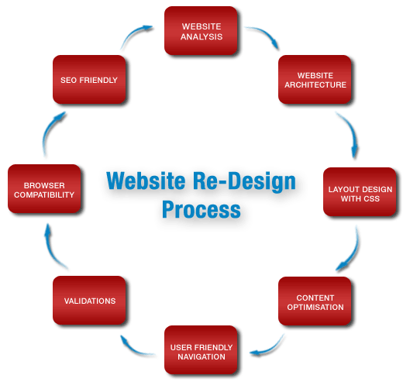

**SOFTWARE TESTING**

# Testing is a process of executing a program with the intent of finding an error. Testing is a crucial element of software quality assurance and presents ultimate review of specification, design and coding. System Testing is an important phase. Testing represents an interesting anomaly for the software. A good test case is one that has a high probability of finding an as undiscovered error.

The test approach is divided into three main phases:

Module testing, integration tests and system testing.

In addition, the system testing includes two sub-phases: functional and usability testing. These planned tests are explained briefly below.

(a) Module testing will perform during coding by using debug messages to check that the written code produces wanted results. An important requirement is that the code will compile with zero bugs.

(b) Integration testing will perform after finish module testing in order to validate if each module can work fine with each other. Integration Test proves that system works as integrated unit when all the fixes are complete.

(c) System testing includes two phases: functional testing and usability testing. These will perform after the product reaches its final version. During functional test phase, the tester will test if the product meets the game requirements. The tester tests the requirements using the use cases listed below in Test Cases section. The usability test will perform to understand how easy it is to use this restaurant website. Any person out of the team members will perform this test by selecting the category and placing the order via call.

**REQUIREMENTS:**

Following are the hardware and the software requirements for our project:

**a) Hardware:**

* + Laptop/Desktop
  + 1.8 GHz or faster processor. Quad-core or better recommended
  + 4 GB of RAM
  + Hard disk space: Minimum of 800MB up to 210GB of available space
  + Video card that supports a minimum display resolution of 720p (1280 by 720)

**b) Software:**

* + Windows 8.1 and above
  + Visual Studio
  + XAMPP server
  + HTML
  + Web Browser
  + Bootstrap
  + MSSQL
  + CSS
  + PHP
  + jQuery
  + JavaScript

**Chapter-3**

**Implementation**

**Screenshots**

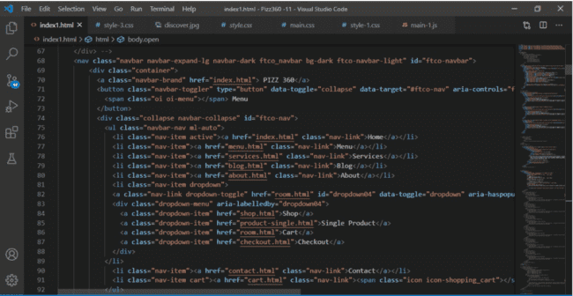

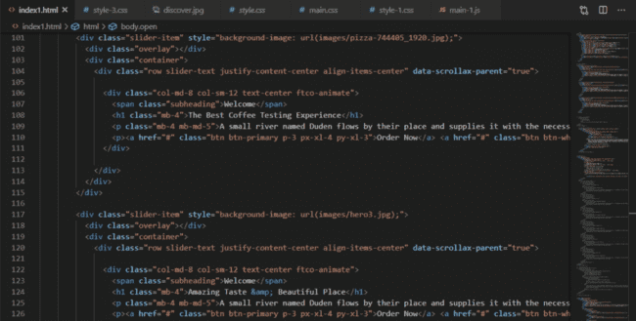

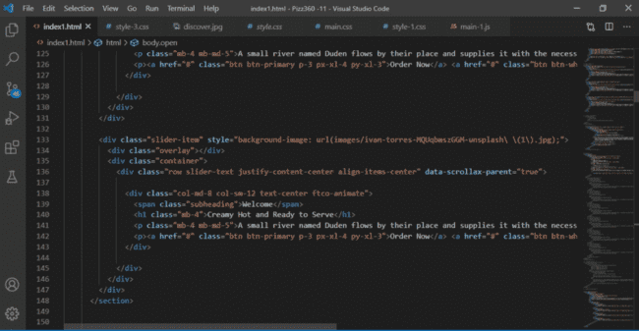

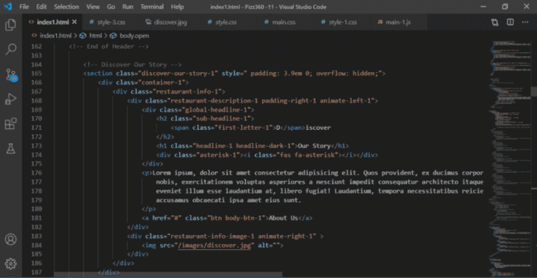

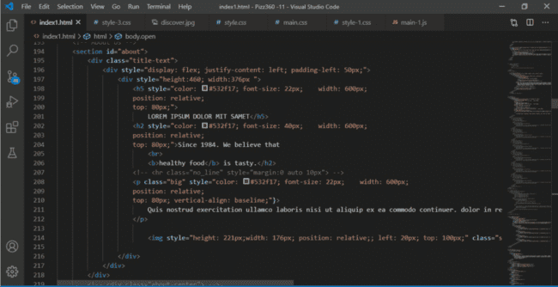

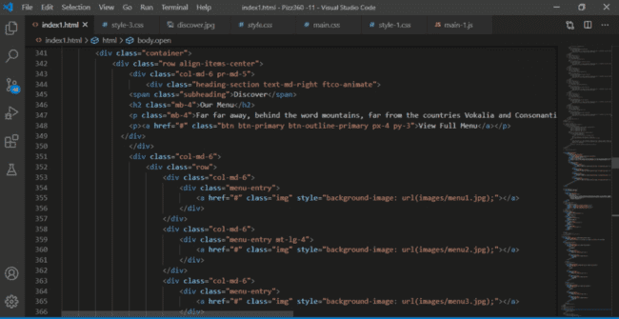

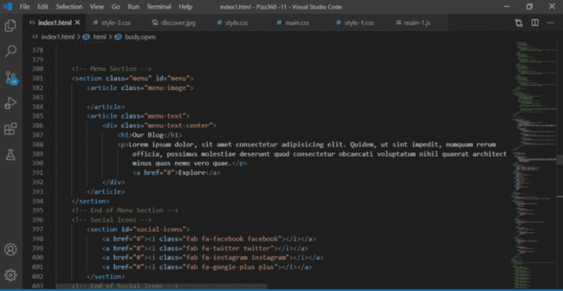

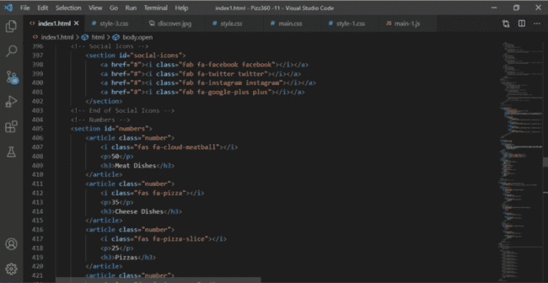

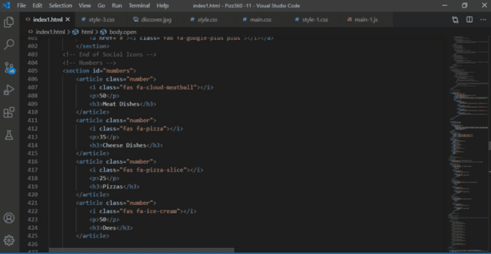

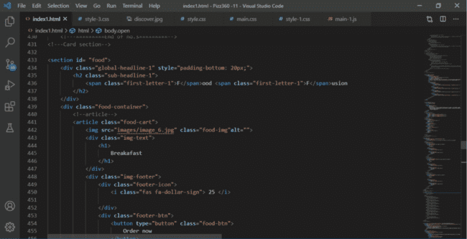

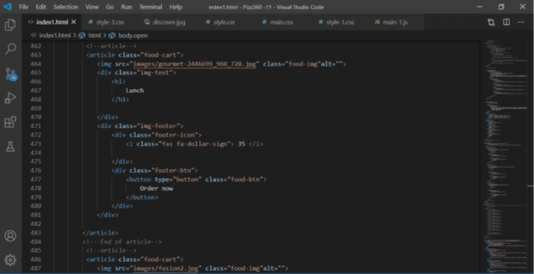

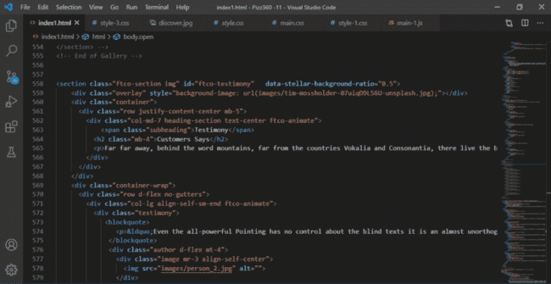

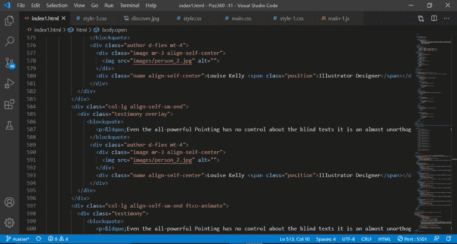

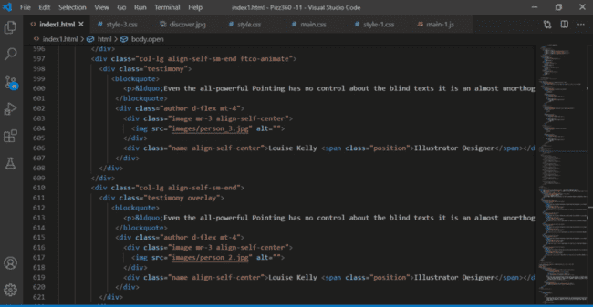

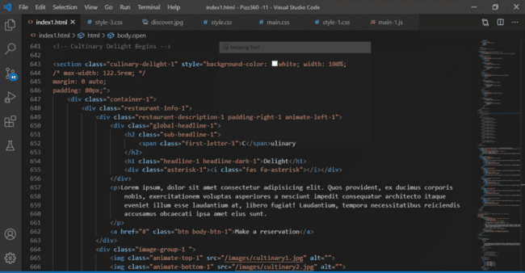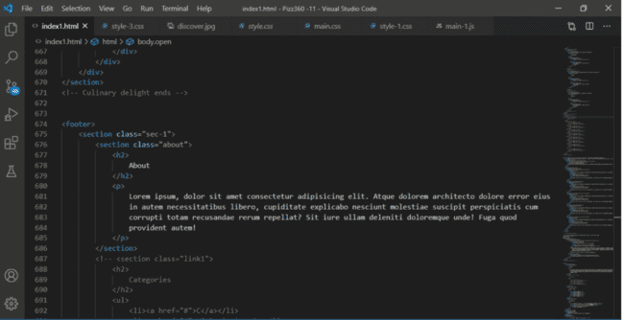

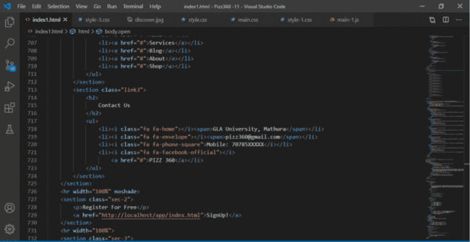

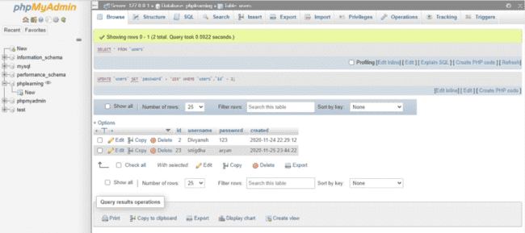

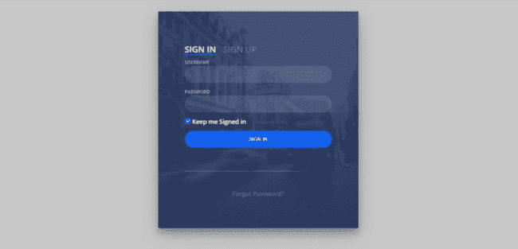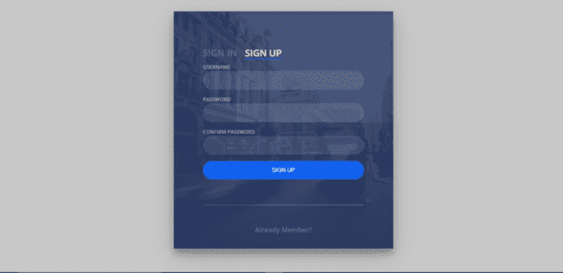

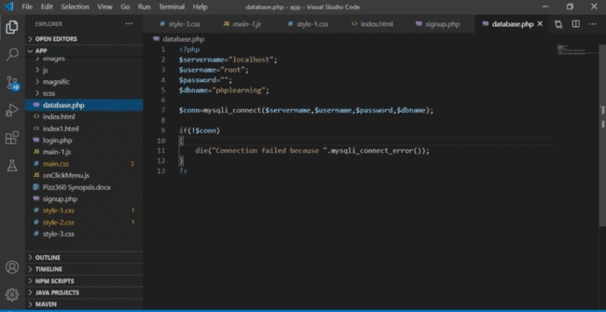

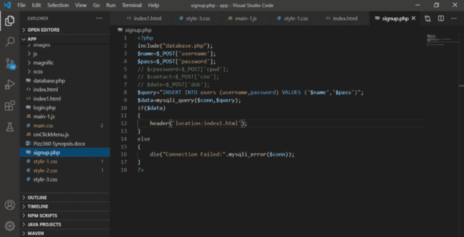

**User Interface**

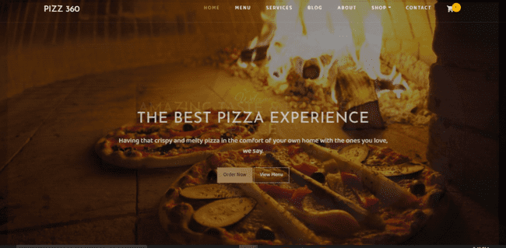

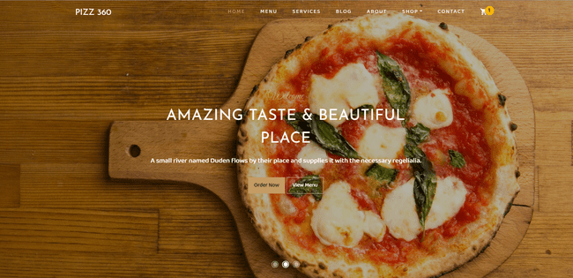

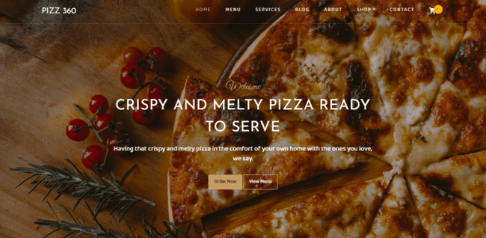

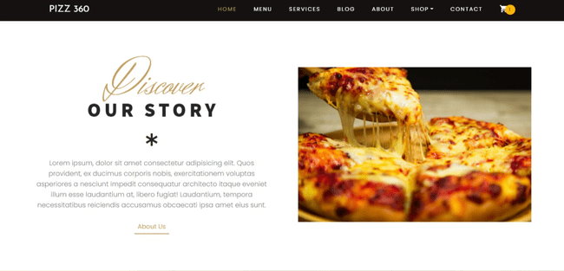

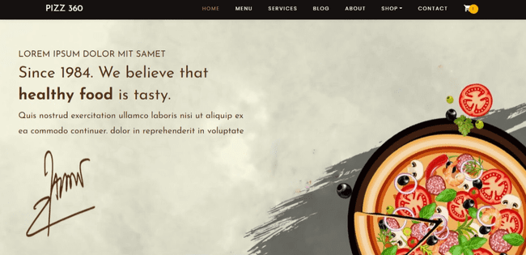

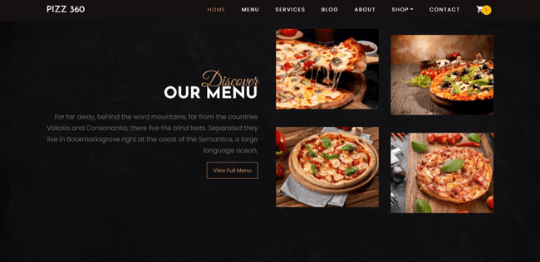

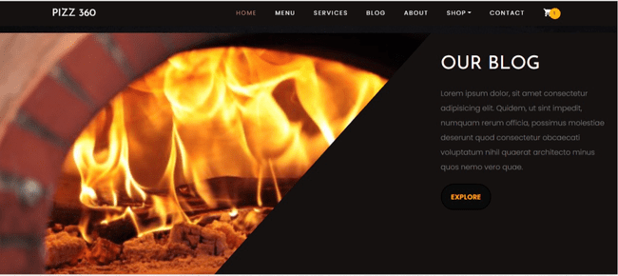

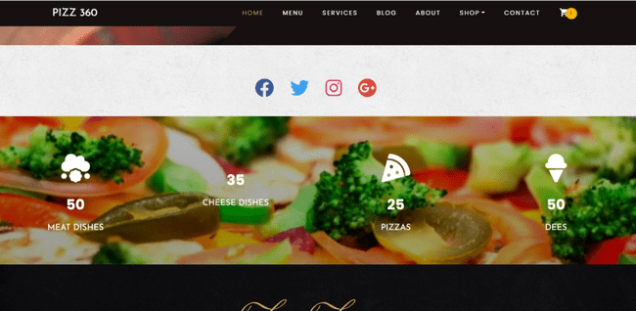

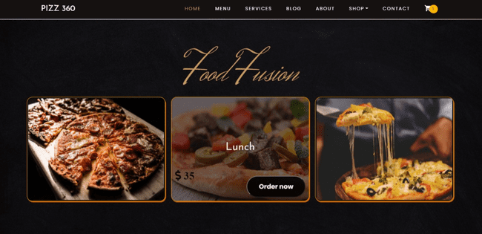

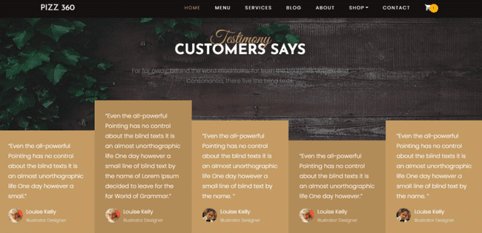

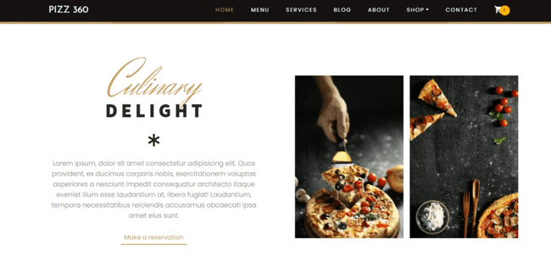

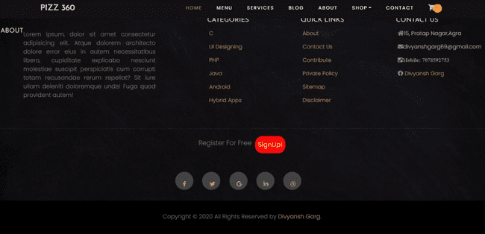

**References**

* <https://www.w3schools.com/>
* <https://stackoverflow.com/>
* <https://github.com/divyanshgarg28/Pizz360>
* [www.bootstrap.com](http://www.bootstrap.com/)
* [www.youtube.com](http://www.youtube.com/)
* <https://github.com/>